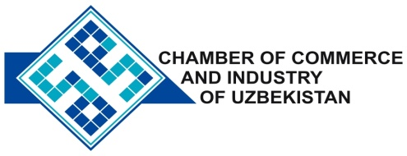

**Commercial offer of Uzbek Products to Foreign Buyer**

Dear Sirs, PSM-020

We offer quotation of Uzbek companies JSC «Tashkent Lok Buek Factory».

**Information about the company:**

The company «Tashkent Lok Buek Factory» was established in 1945 and to date is the largest manufacturer of paint products in Central Asia.

**List of products:**

Enamels

Paints for roofs

Water-dispersion paints

Varnish

Primer

Solvent

Pigment Yellow Iron Oxide

PVA glue

**Benefits:**

The plant produces a wide range of products of paints and varnishes, technically rearm and introducing new production technology.

**Terms of delivery:** FCA Tashkent

If you are interested, we are happy to provide additional information in accordance with your request.

E-mail: [export@chamber.uz](mailto:export@chamber.uz)

Website: [www.chamber.uz](http://www.chamber.uz)

Export Promotion Department.

Chamber of Commerce of the Republic of Uzbekistan